Lab 12: Setting Up a Load Balancer

1 Set Up the Web Servers

* 1. Set Up the Web Server on Windows

1. Click on the WinOS tab to access the WinOS.
2. Log in with credential provided
3. Launch the server manager, once it opens click the manage button, and then select Add Roles and Features. To add the IIS Role to the server.
4. On the first Select installation type page, click Next.

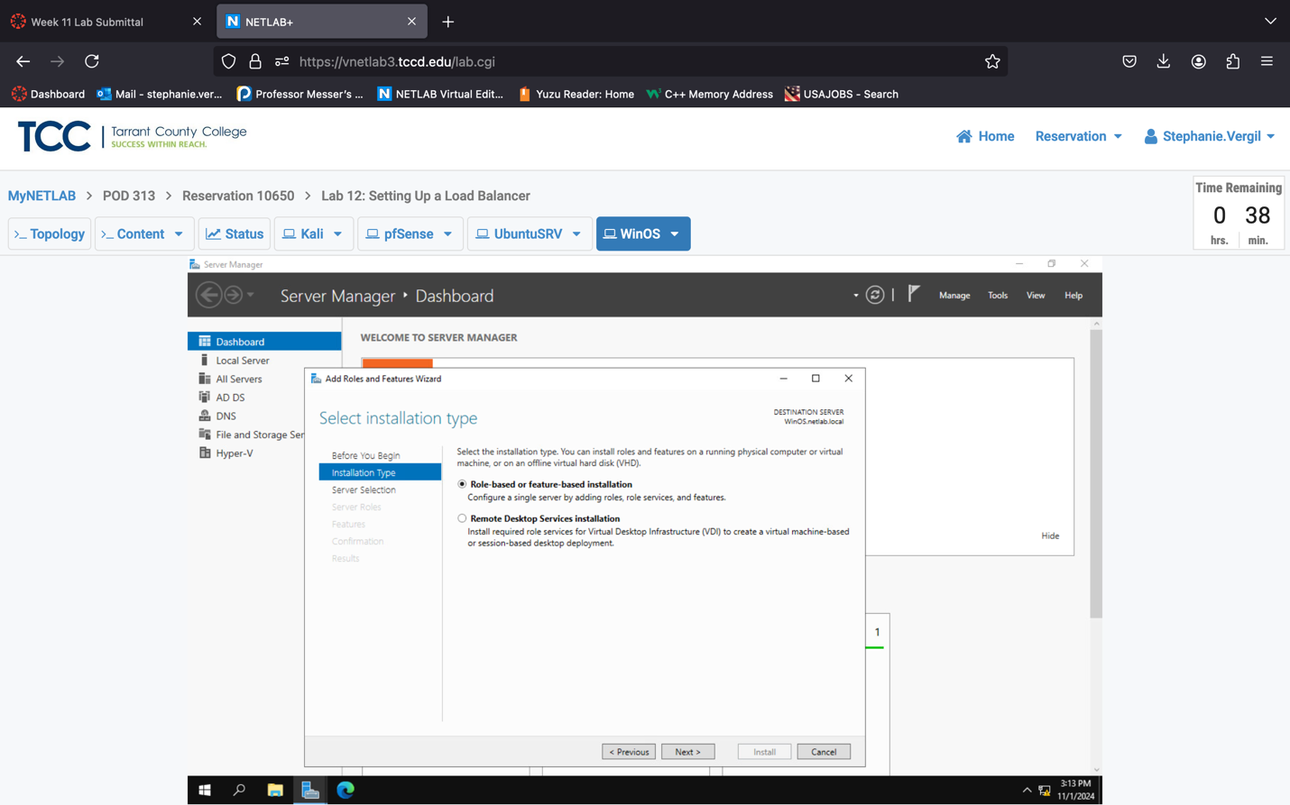

1. Make sure WinOS.netlab.local is selected, click Next.

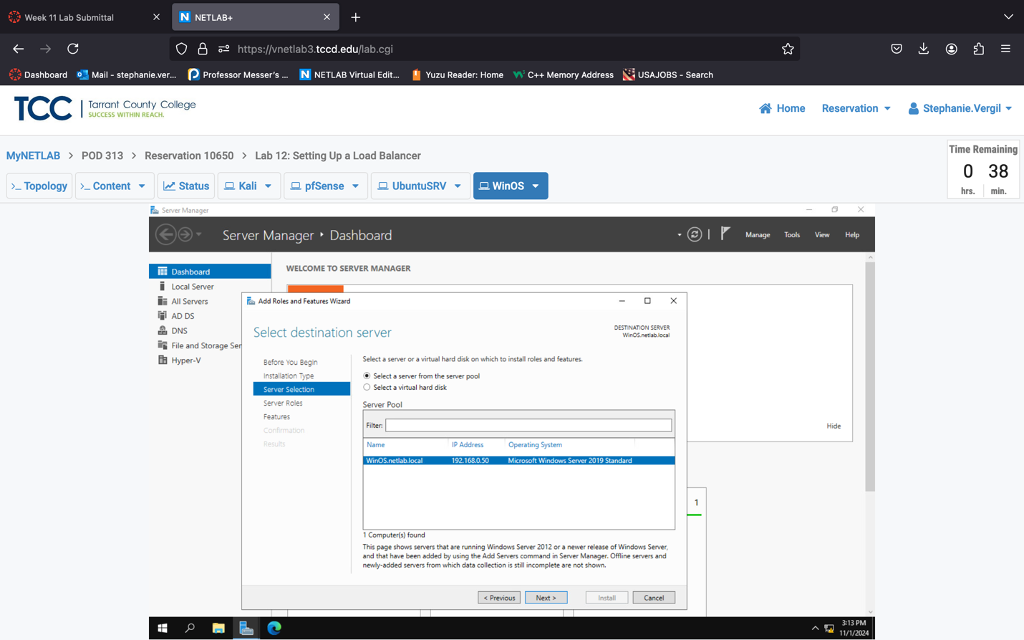

1. At the Select server roles step, check to select Web Server (IIS).
2. In the pop-up window, leave the default settings and click the Add Features button.

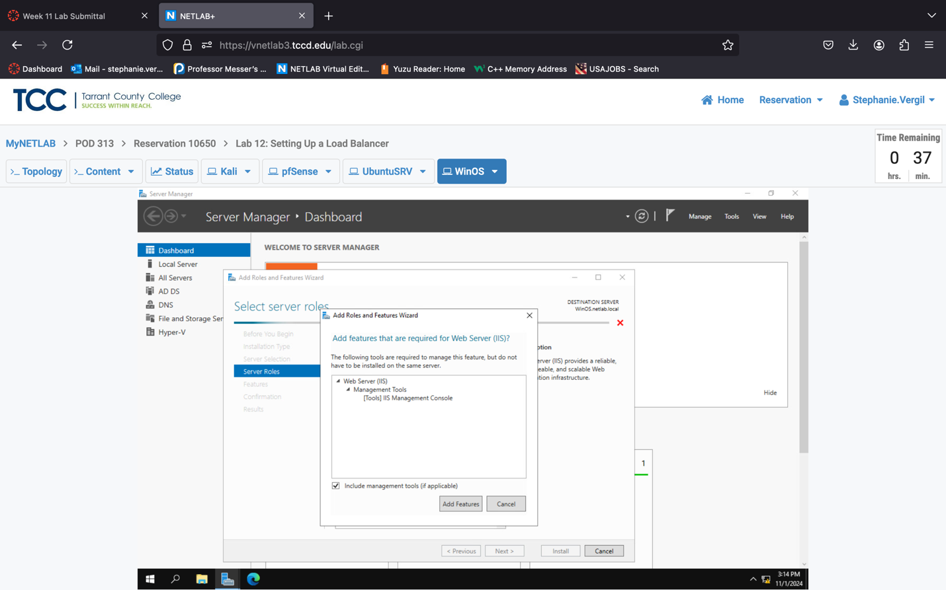

1. You will be brought back to the Select server roles page; click Next.

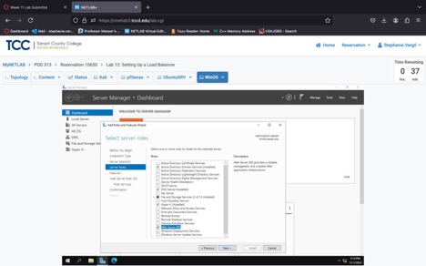

1. On the Select features page, click Next.

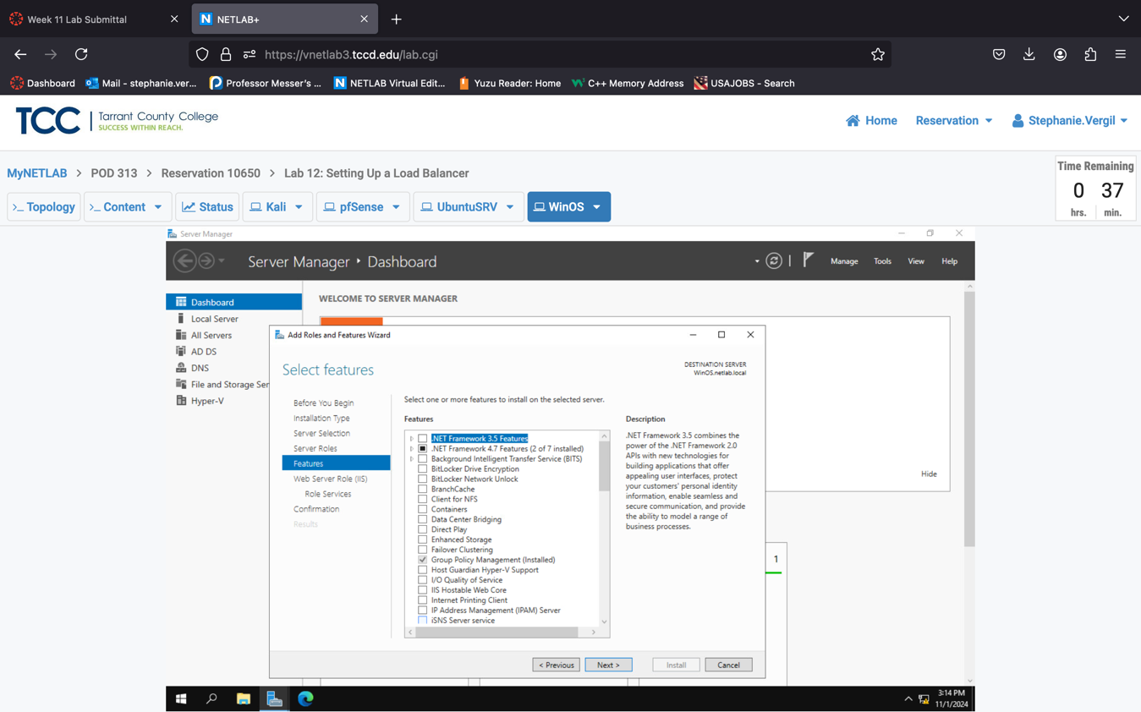

1. On the Web Server Role(IIS) page, click Next.

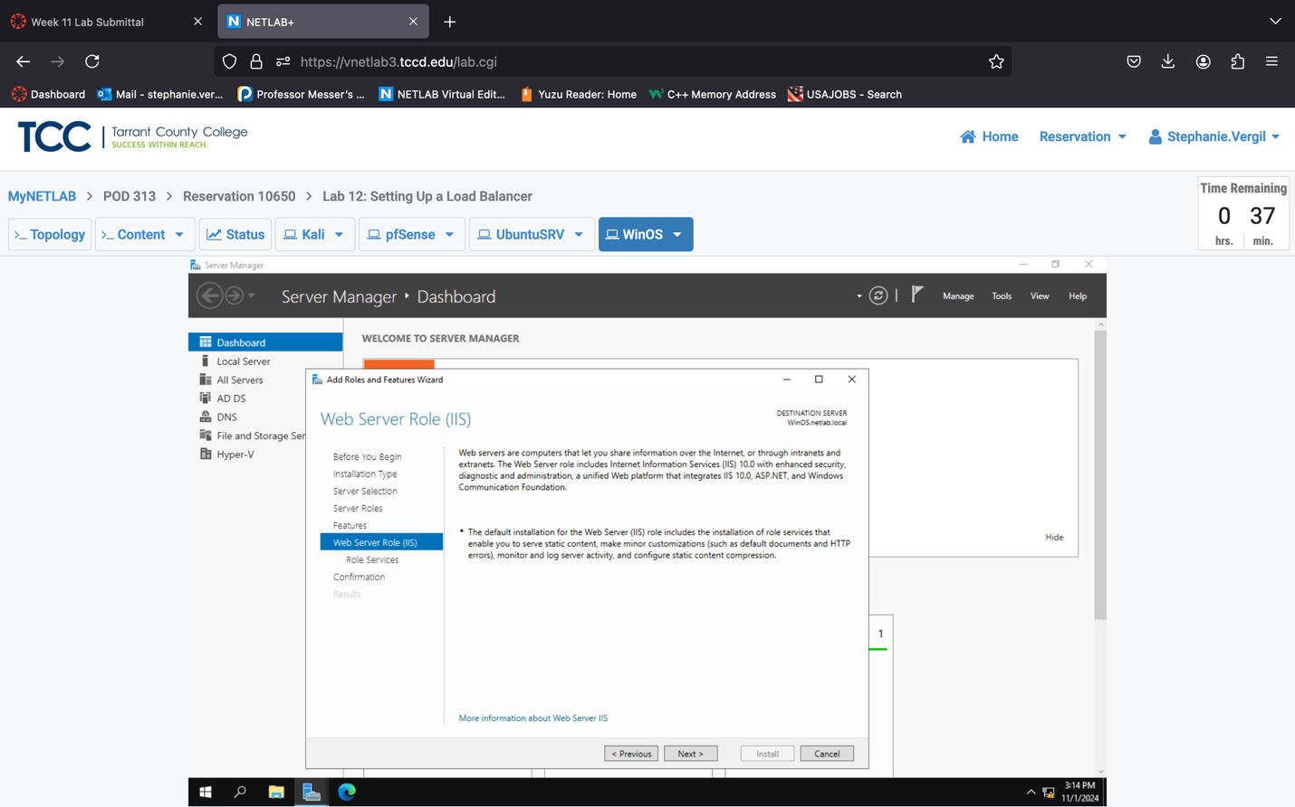

1. On the Select role services page, leave the default settings and click Next
2. At the Confirmation installation selections page, click Install.

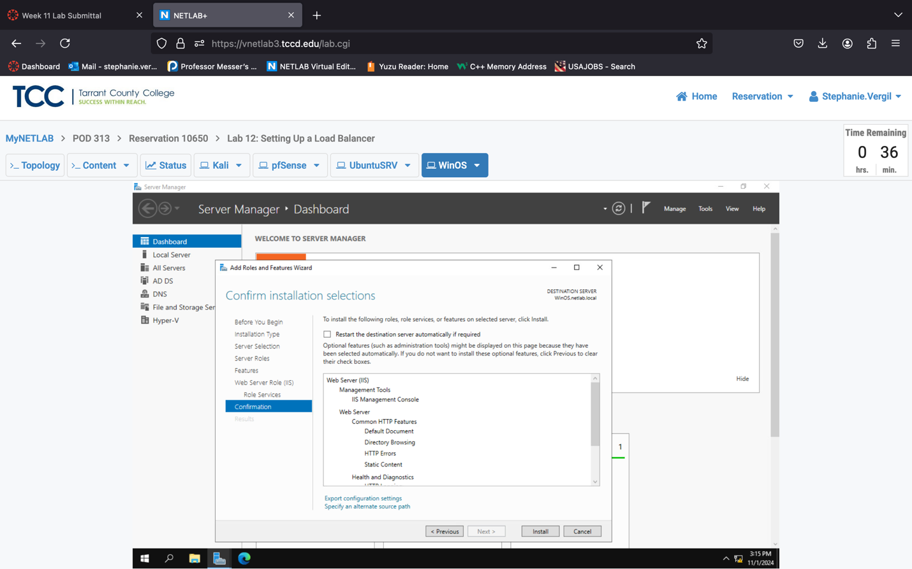

1. The installation should take 3 - 5 minutes to complete. Once finished, click the Close button.

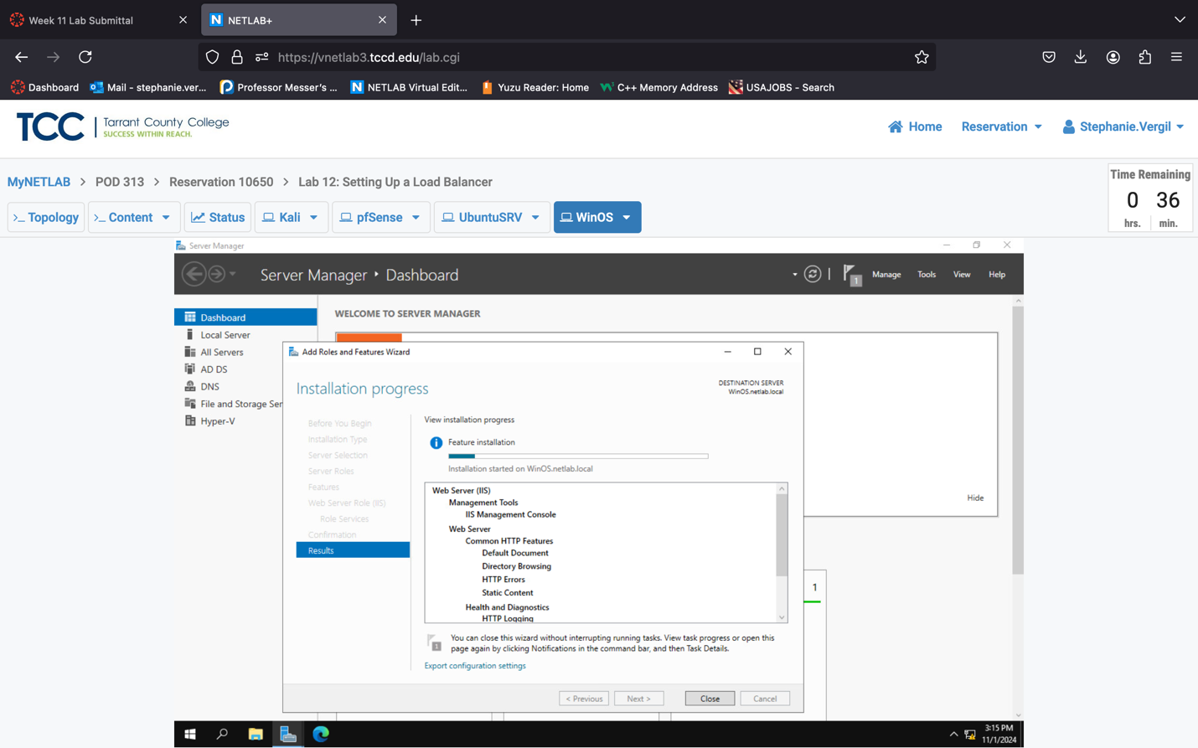

1. You will be brought back to the Server Manager window. IIS Web server should be running in the background now. Next, let’s quickly add a simple index page to our web server. Click the Magnifier icon in the taskbar and type notepad.
2. In the result, right-click on Notepad and select Run as administrator.
3. When prompted by User Account Control, answer Yes.

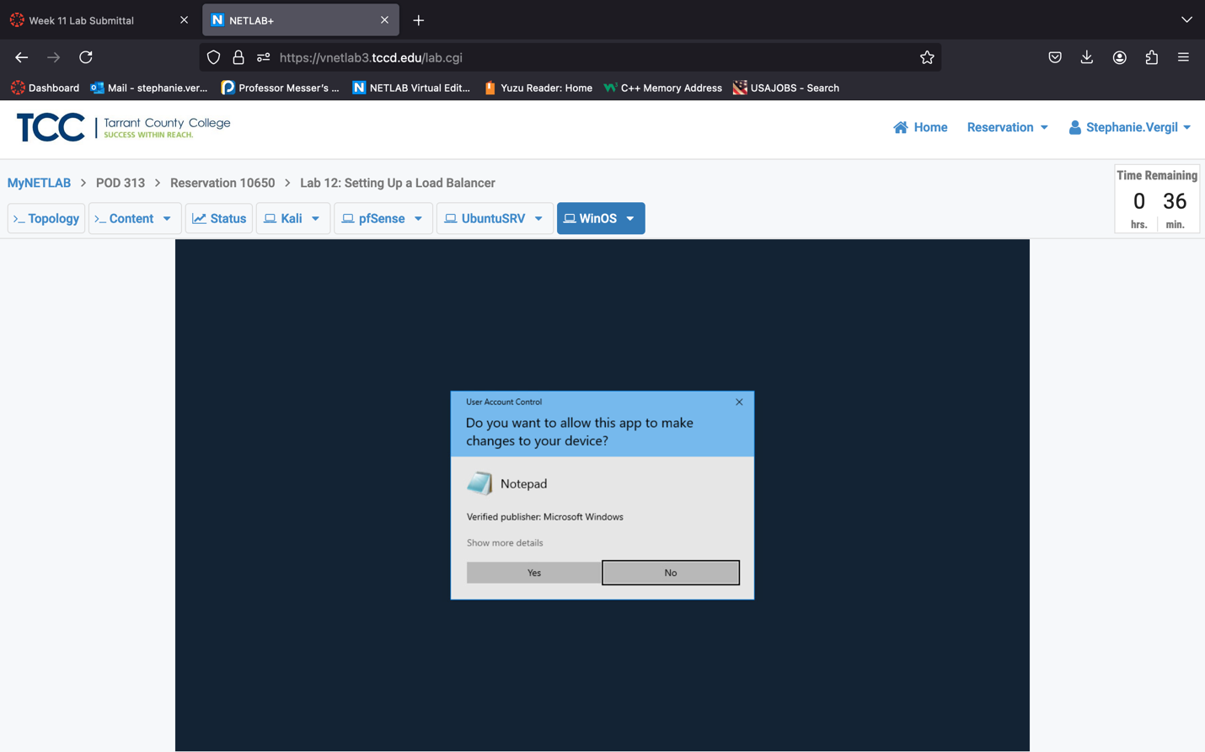

1. In the Notepad window, type: Hello, this is WinOS server!

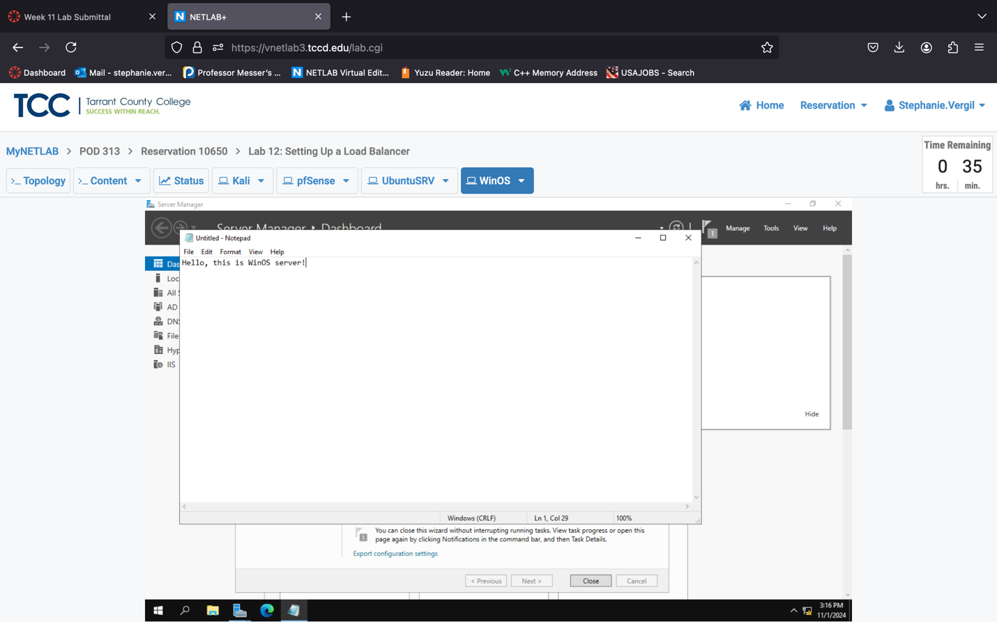

1. In the program menu, click File, then select the Save As… option.
2. The Save As window opens. On the left side, click This PC. Then, scroll down on the right side and double-click Local Disk (C:).
3. Double-click inetpub to open it, then double-click wwwroot to open it.
4. At the bottom of the Save As window, type index.html as the filename. Change the Save as type to All Files (*.*), change the Encoding to UTF-8. At last, click Save

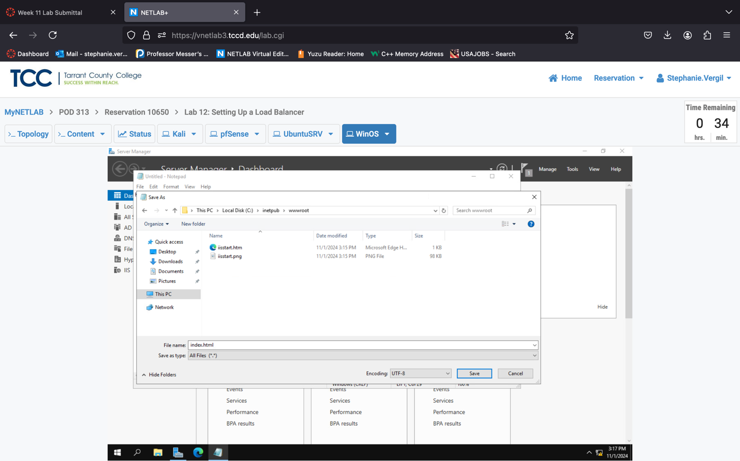

1. The index page is set. Let’s check it before we move to the next section. Click on the Edge icon to open a browser window.
2. In the address bar, type localhost, and press Enter. You should see the index page showing the words we added in step 17.

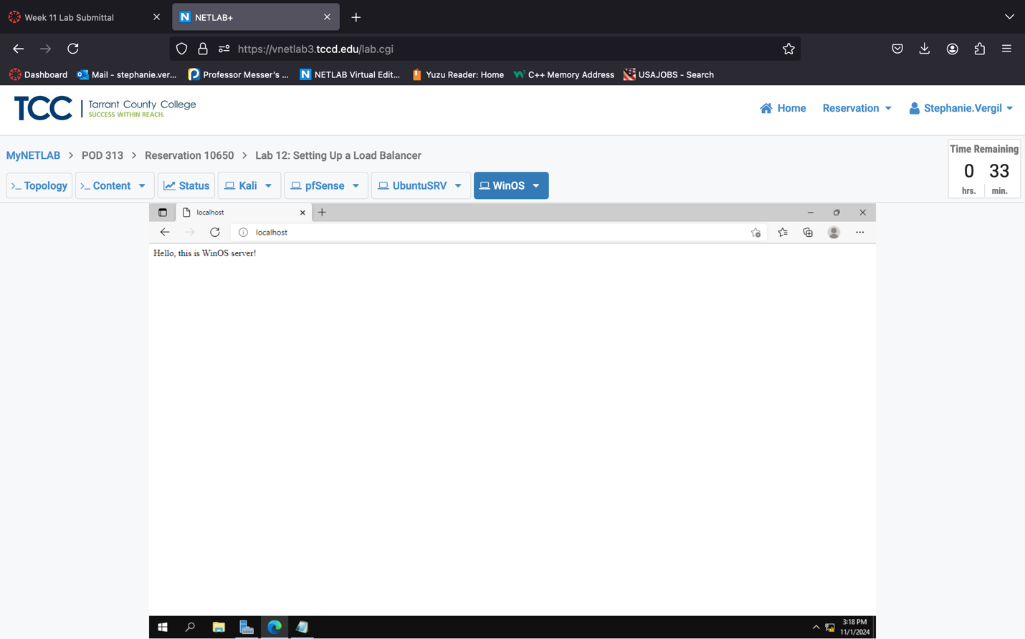

1. Leave everything in its place and proceed to the next section.
   1. Set Up Web Server on UbuntuSRV
2. Click on the UbuntuSRV tab to access the Ubuntu Server.
3. Log in with credential provided
4. Launch terminal
5. Type the following command in the Terminal window:

cd /var/www/html

1. Let’s check what’s inside the folder. Type ls.

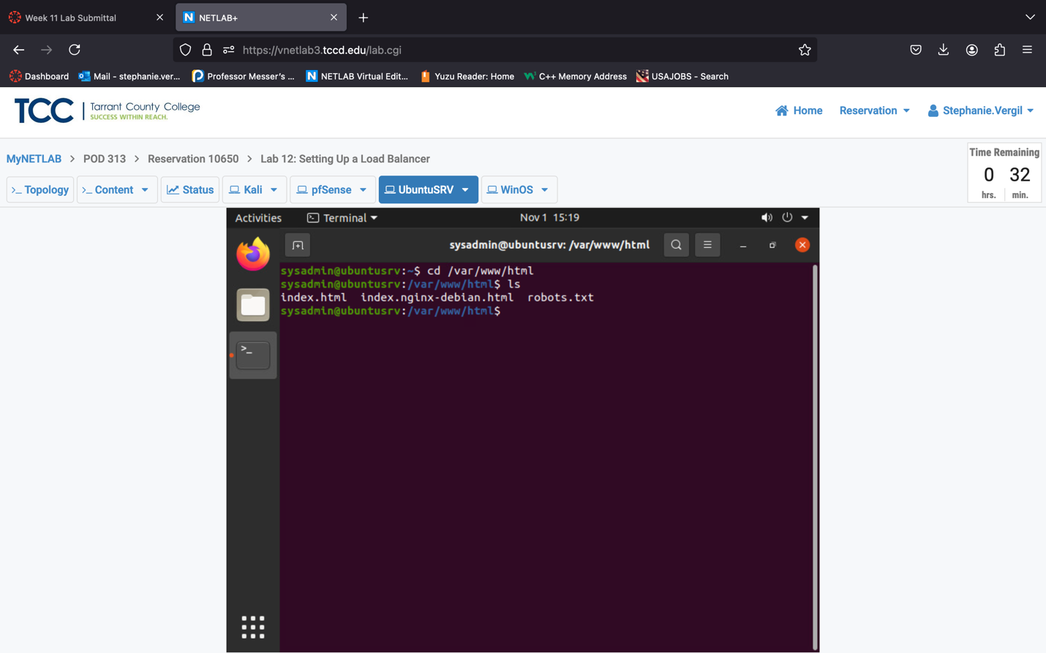

1. It shows there are three files. It looks like there is an nginx server running. Let’s do some cleanup and start to build our own web server. Type and run the following commands:

sudo rm index.html

sudo rm index.nginx-debian.html

1. Then, let’s stop the nginx service by typing sudo service nginx stop

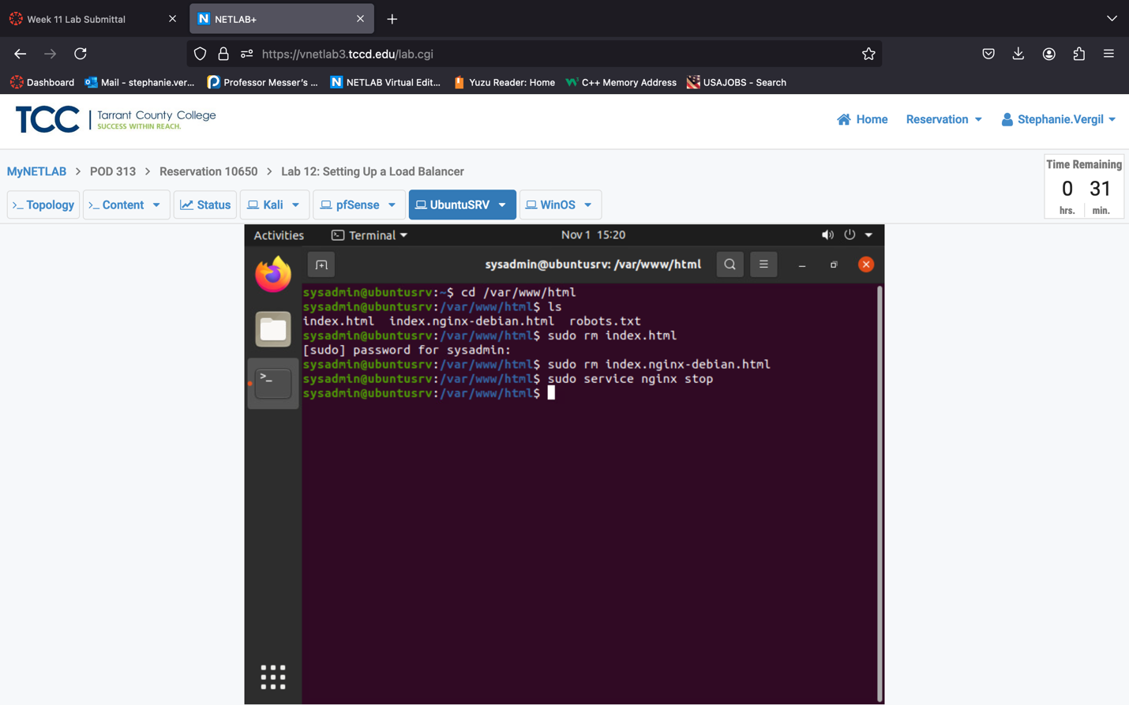

1. We will now add an index page. Type sudo index.html and you will enter the nano text editor. Type in the words: Hello, this is the UbuntuSRV server!

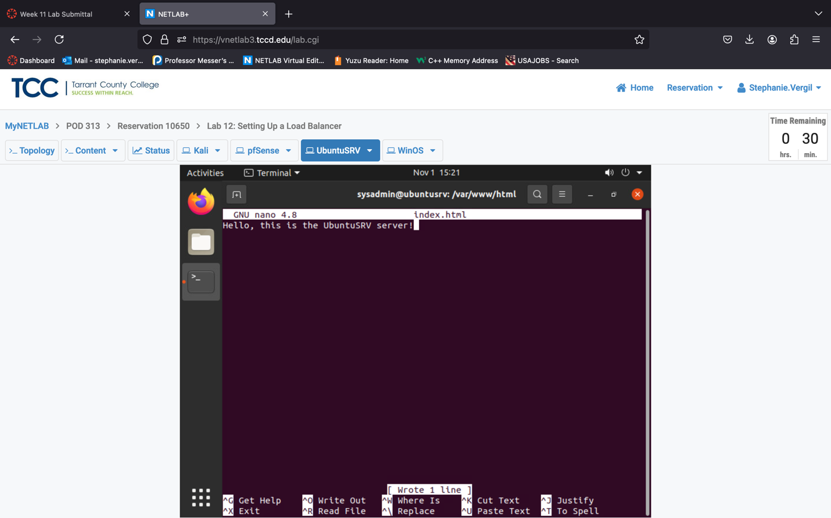

1. Press Ctrl+S to save, and then Ctrl+X to exit.
2. Now, let’s start the web server. Type sudo service apache2 start, this will start the apache service and open port 80.

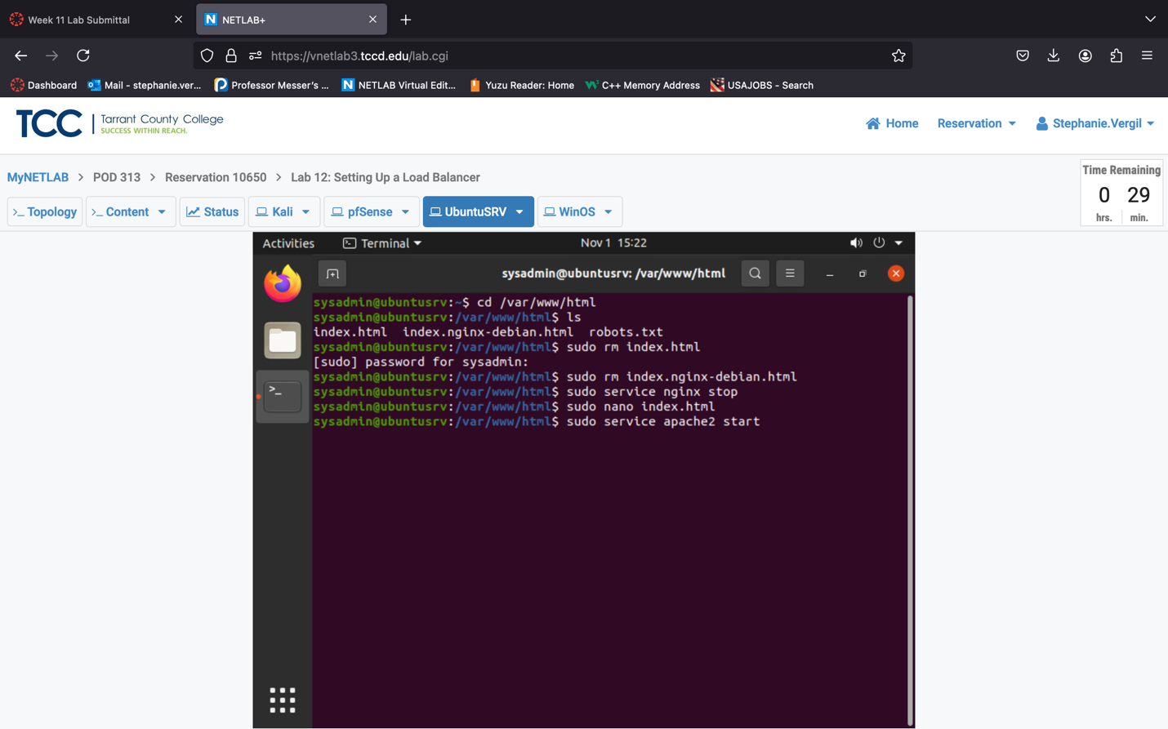

1. Click on the Firefox icon to start a browser. Same as before, go to address localhost to verify the web server is running.

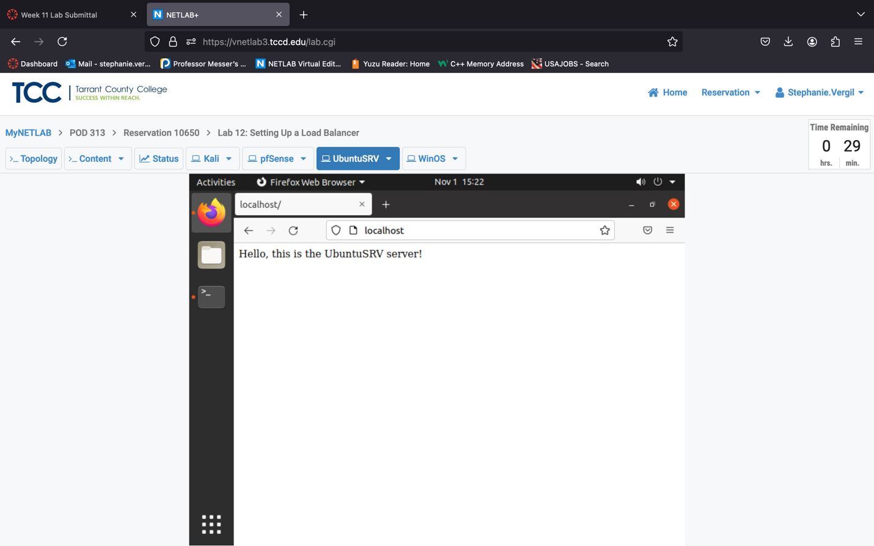

2 Set Up the Load Balancing

2.1 Set Up Load Balancing

1. Launch Kali VM
2. Log in with credentials provided
3. Click the browser icon to start the web browser.
4. In the address bar, type 172.16.1.1, then press Enter to open the pfSense login page. Log in with credentials provided. If the browser offers to save the password, click Don’t Save.

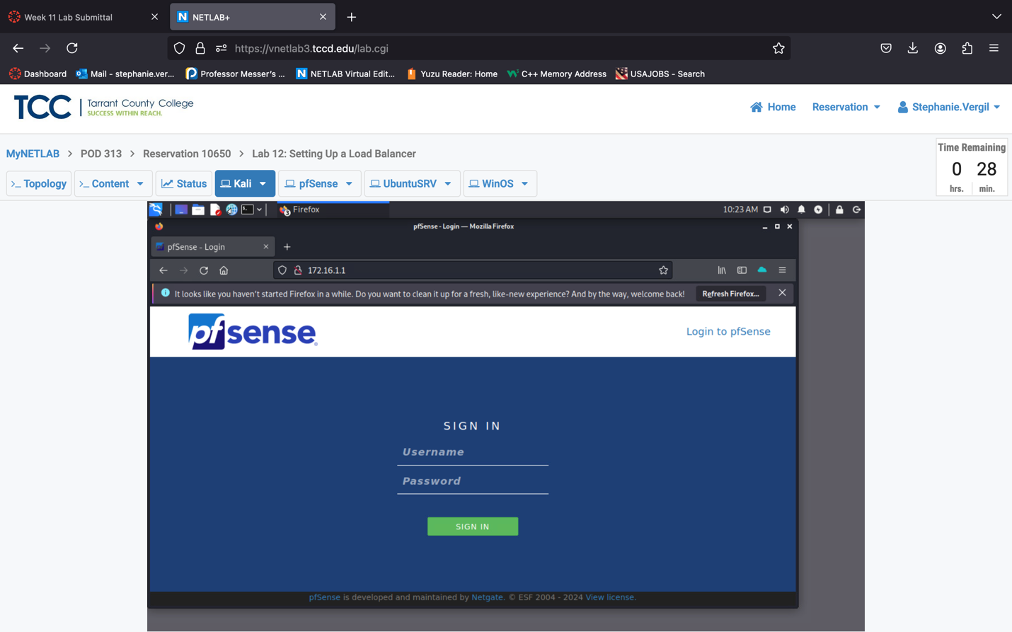

1. You will see the default Dashboard page. At the top, click on Services and select HAProxy.

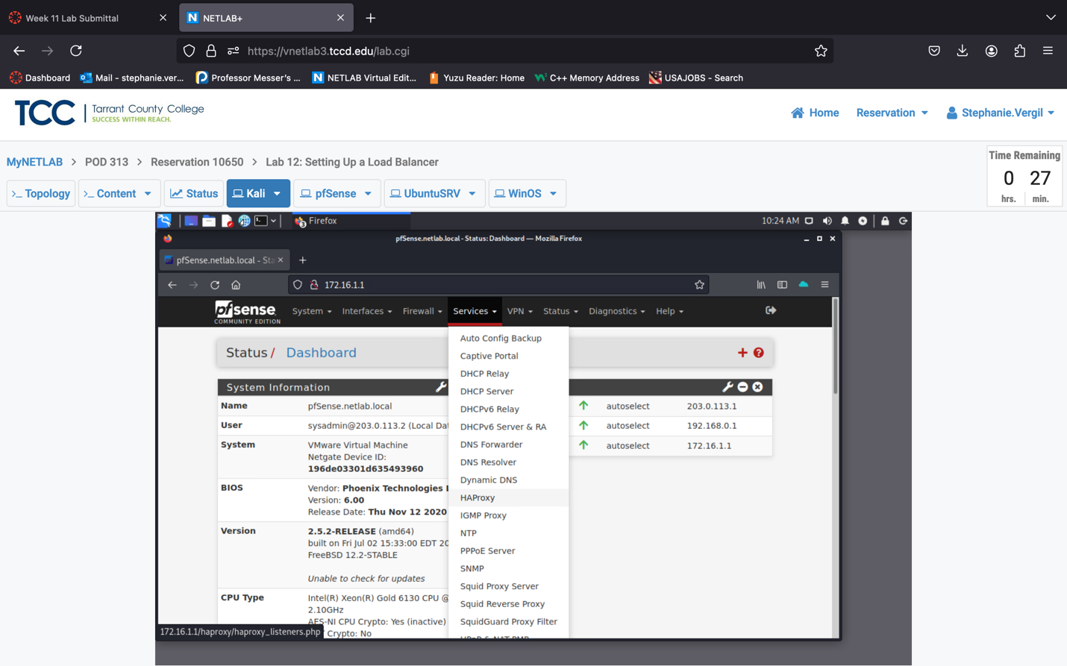

1. We will be configuring the Backend first, then configuring the Frontend. Click the Backend tab, then click the Add button.
2. In the Name field, to make it easier to remember, we will put WebServerBackendPool. Then, in the Server list area, click the down-arrow to add a server.
3. After you click the arrow, the page will expand. Fill in the blanks using the following information

(You’ll need to scroll right to see all fields):

a. Name: WinOS

b. Address: 192.168.0.50

c. Port: 80

d. Weight: 50

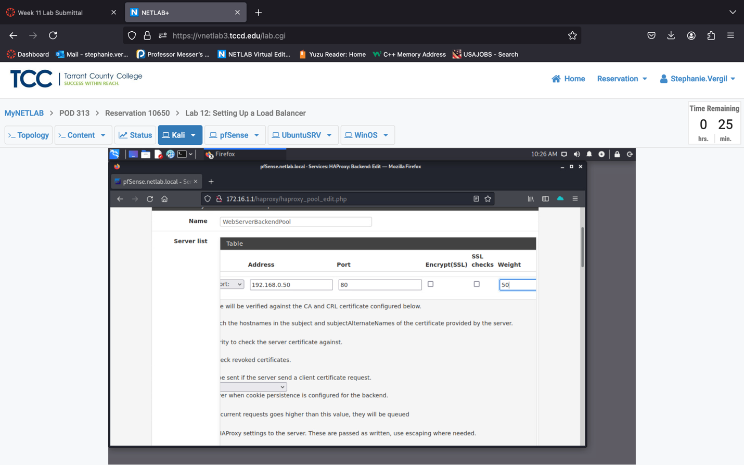

1. Once finished, click the arrow again to add another server to the pool. Fill each field with the following information:

a. Name: UbuntuSRV

b. Address: 172.16.1.10

c. Port: 80

d. Weight: 50

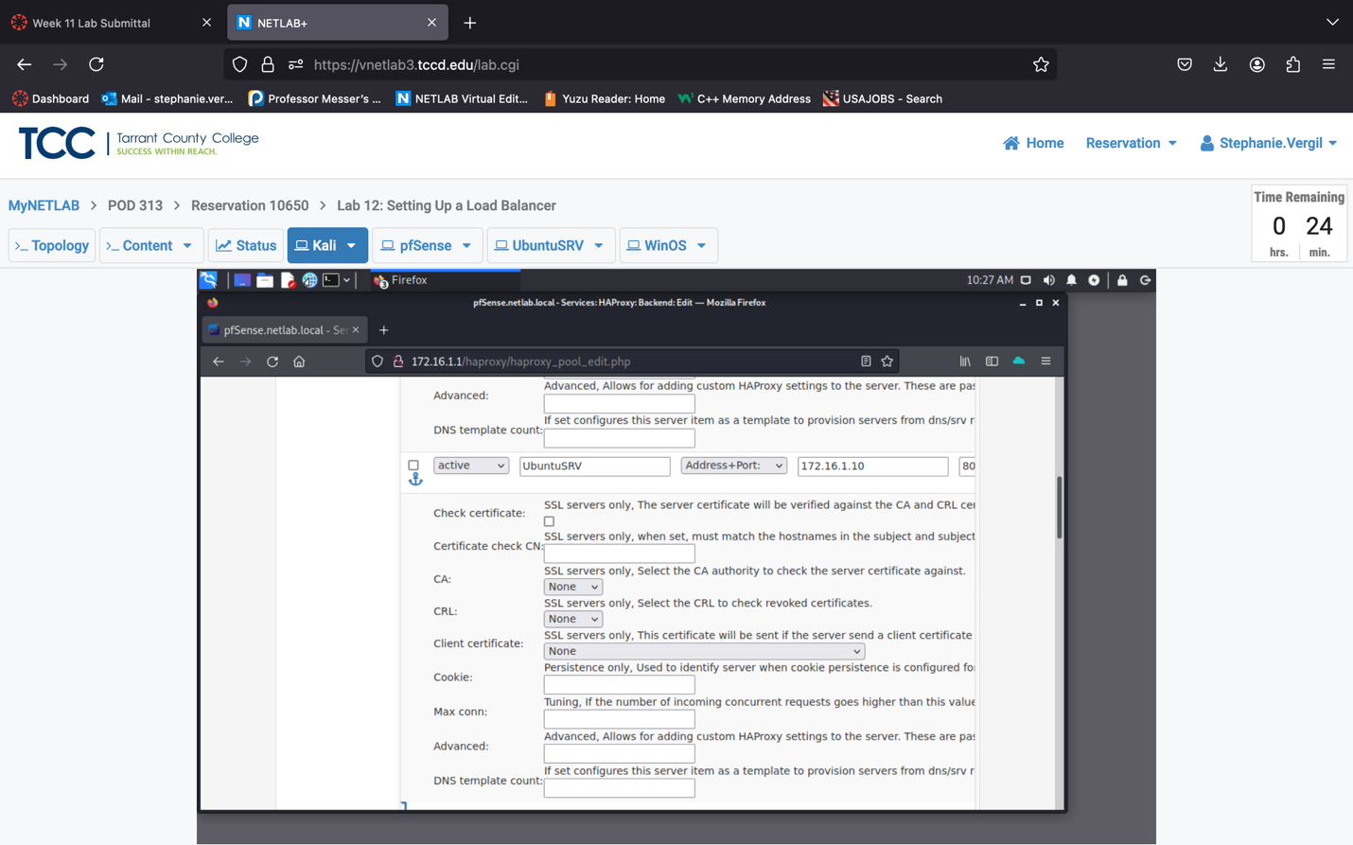

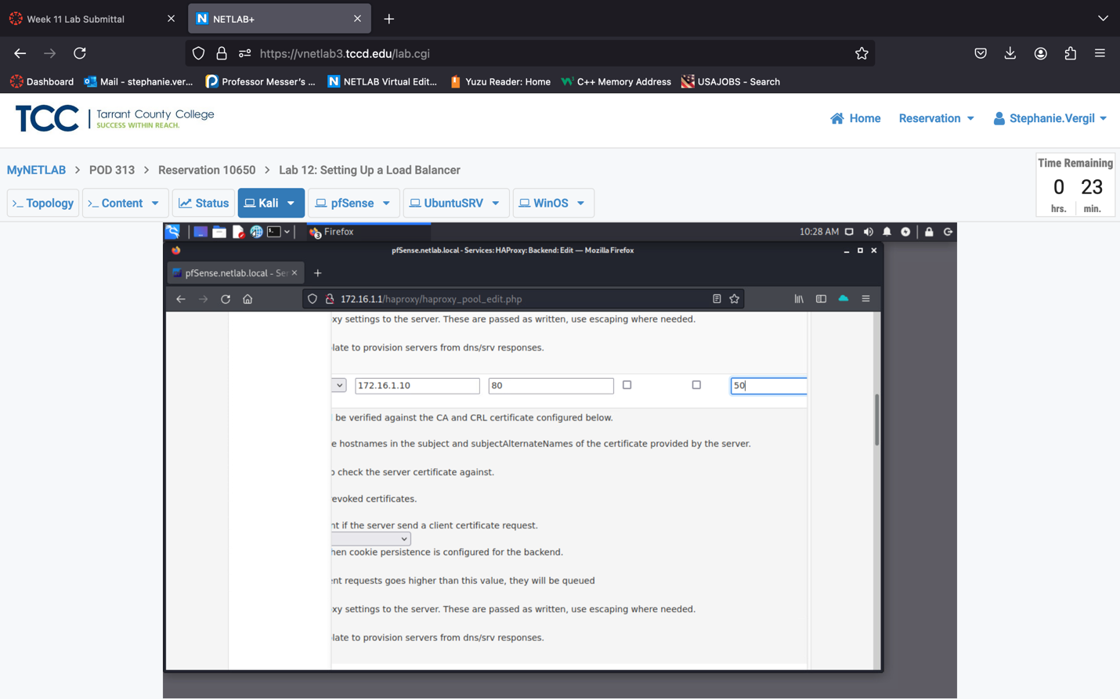

1. Next, we will choose the Load Balancing option. Click the + sign to expand the area to show options. Click to select Round robin.

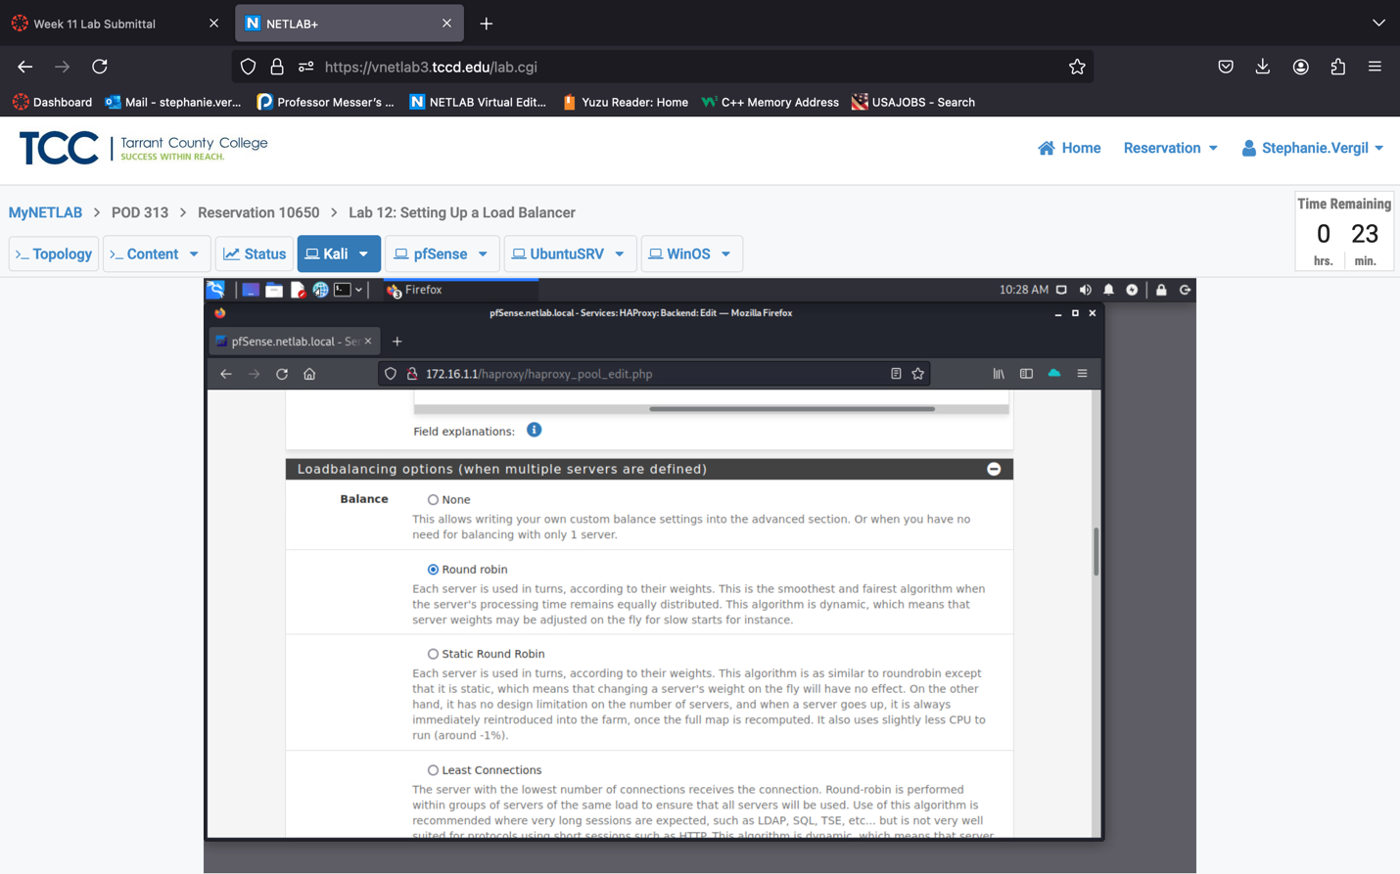

Note: Round robin simply means the load balancer will be alternating the

servers in the server pool depending on their assigned weights.

1. Leave the rest of the configurations untouched. Scroll down to the bottom and click the Save button.

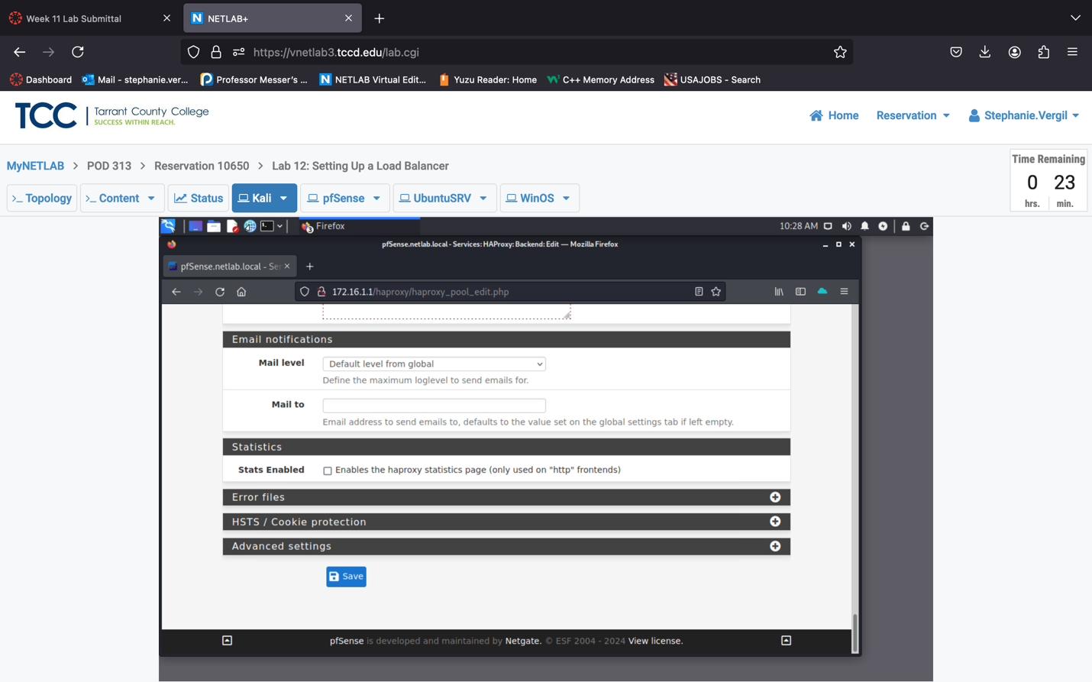

1. You will be brought back to the Backend tab. Notice the banner message prompting us the configuration has been changed; click the green Apply Changes button.

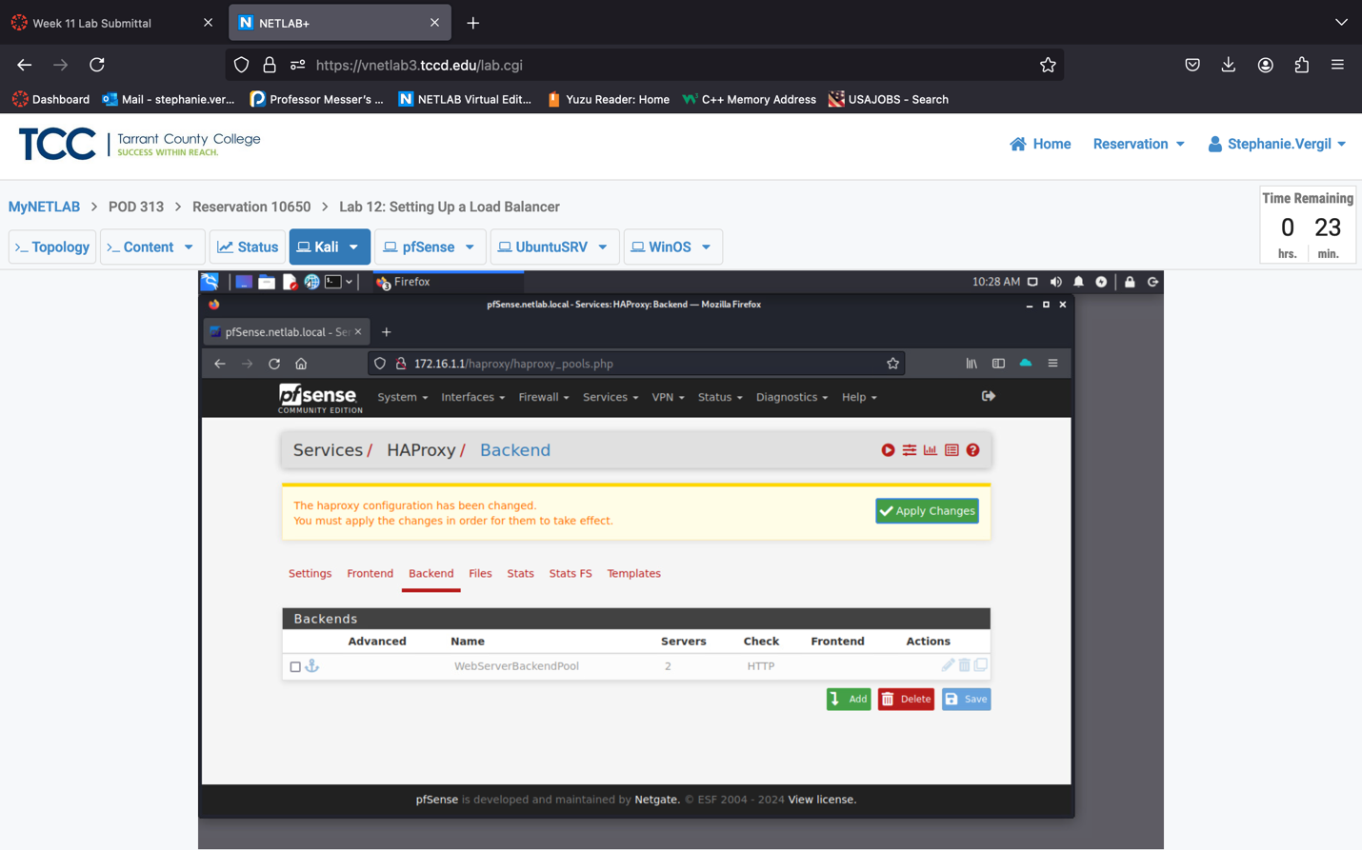

1. Click the Frontend tab, then the Add button to create an entry.
2. Click the Frontend tab, then the Add button to create an entry. In the Edit HAProxy Frontend section, fill the following information in each field:

a. Name: WebServerFrontend

b. Description: This is the external access point of the webserver.

c. Status: Active

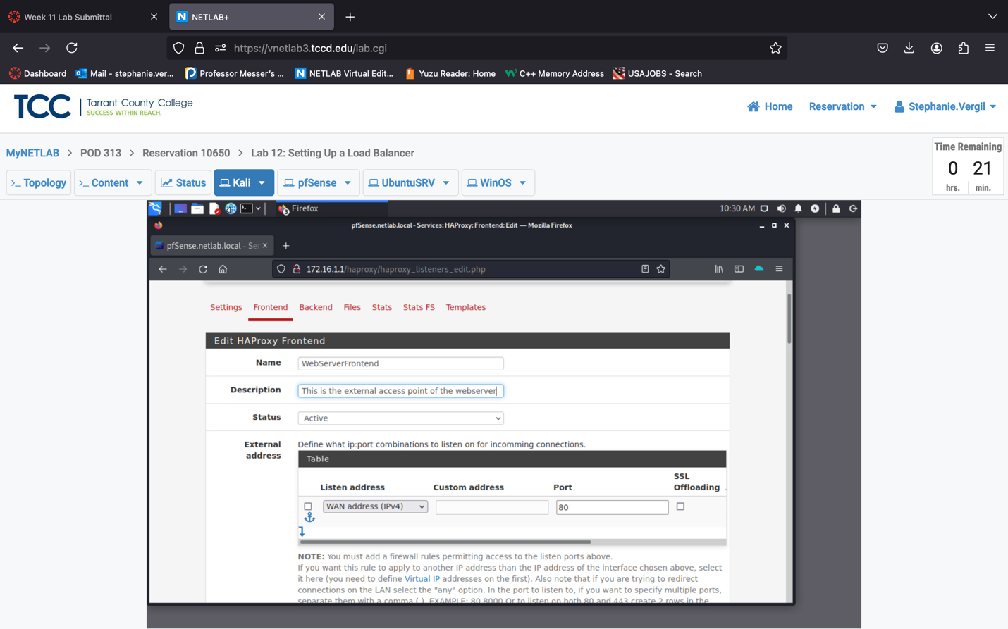

1. In the External address, leave its default setting untouched
2. Scroll down to the right above the Stats options section, click the dropdown menu to select WebServerBackendPool as the Default Backend

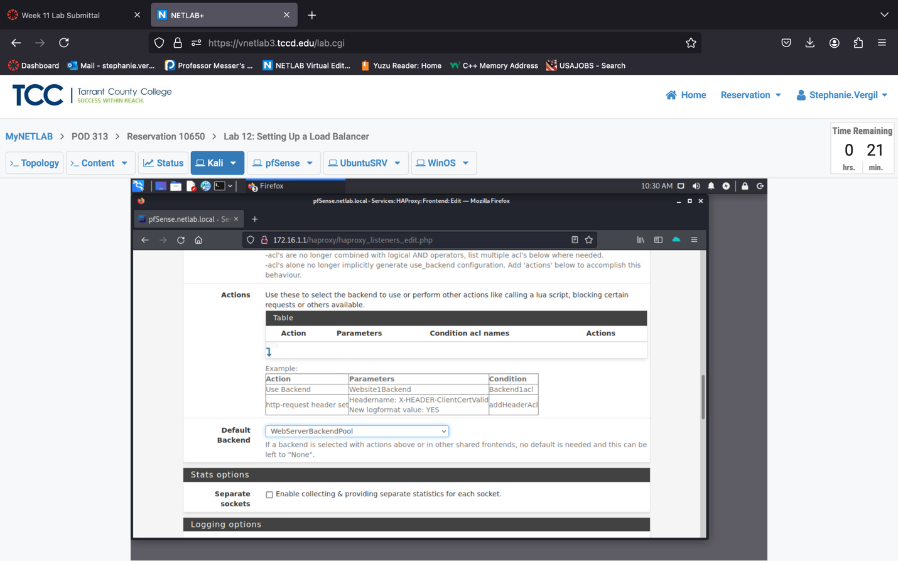

1. Leave the rest of the configurations untouched. Feel free to check and learn any of the other configurations. Once done, scroll down to the bottom and click the Save button.
2. Once again, you will see the banner message prompting us the configuration has been changed; click the green Apply Changes button. Notice the address 203.0.113.1:80; remember this. It will be the external/virtual server address we are visiting in a later section.

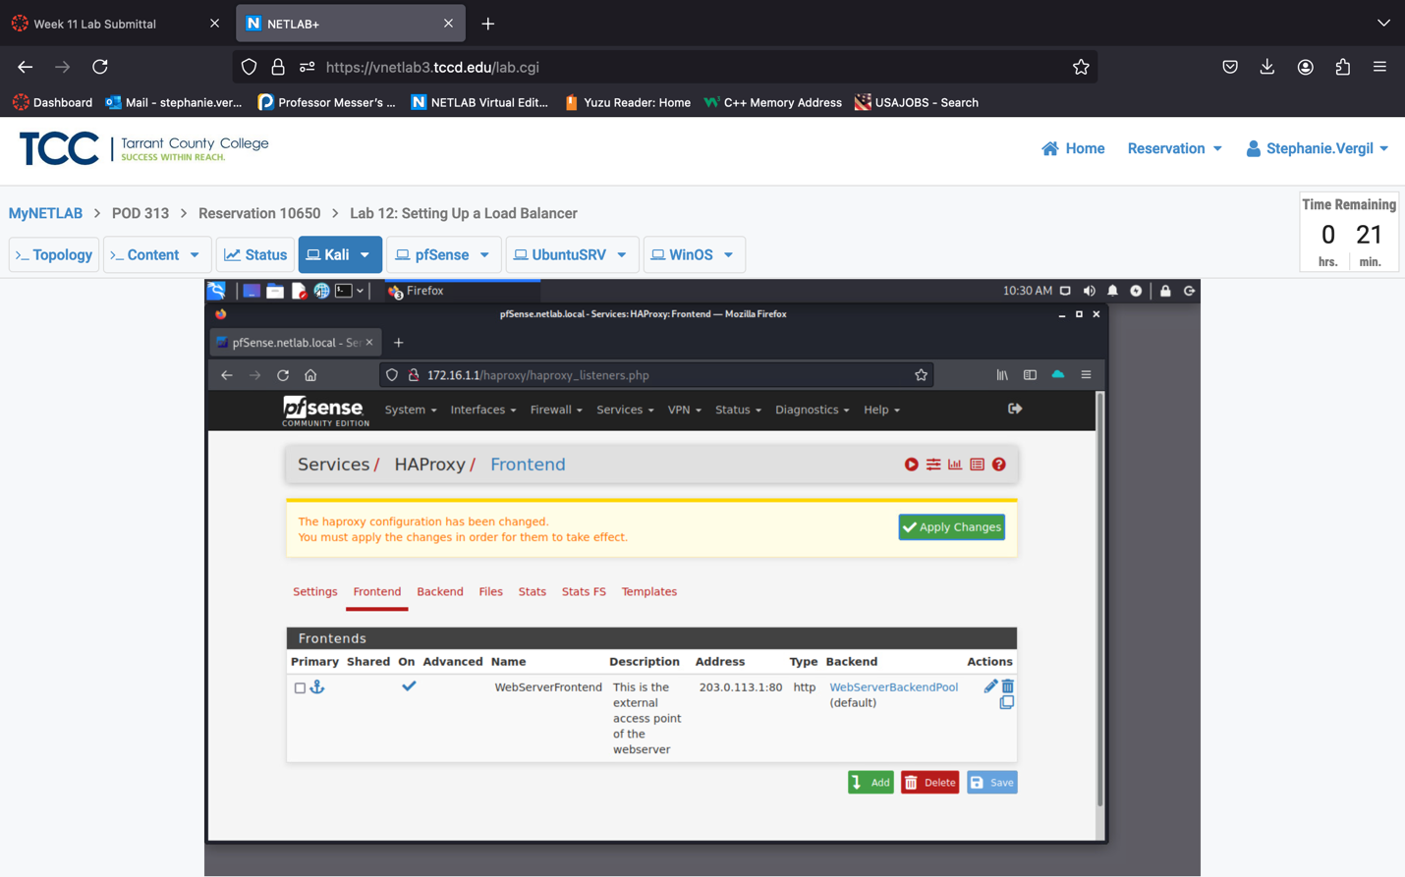

1. Now, let’s activate the Load Balancer. Click on the Settings tab, then check the Enable HAProxy box, fill in the Maximum connections as 10.

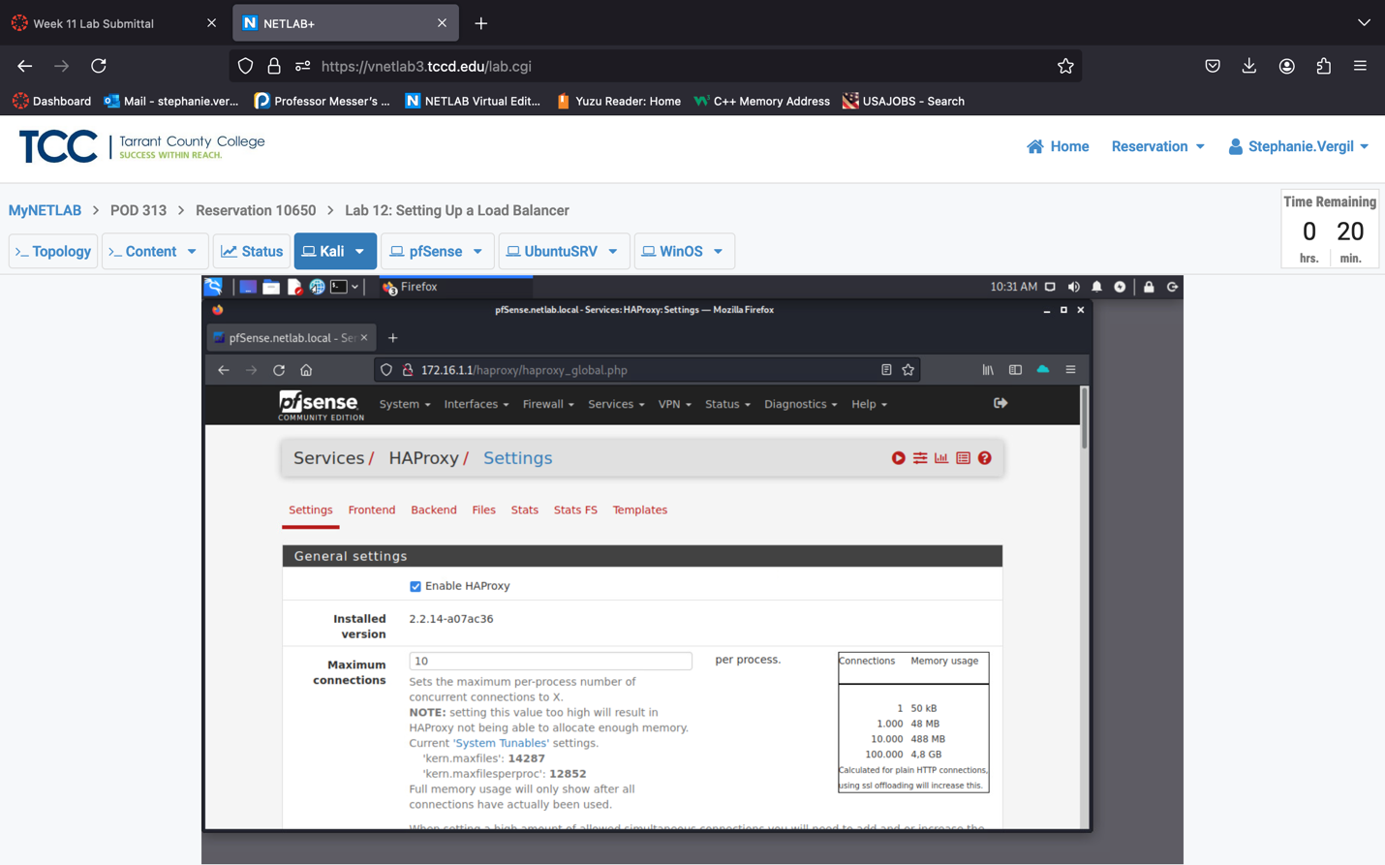

1. Leave the rest of the configurations untouched. Feel free to check and learn any of the other configurations. Once done, scroll down to the bottom and click the Save button.
2. The banner message will pop once more; click the green Apply Changes button. We have finished setting up the Load Balancing

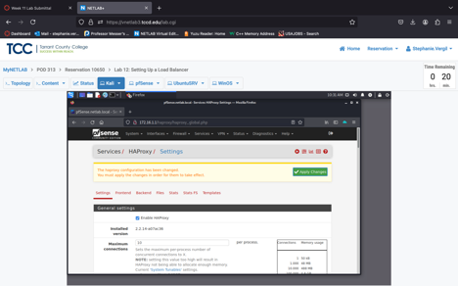

1. Ignore the warning message if it is shown. Proceed to the next section.

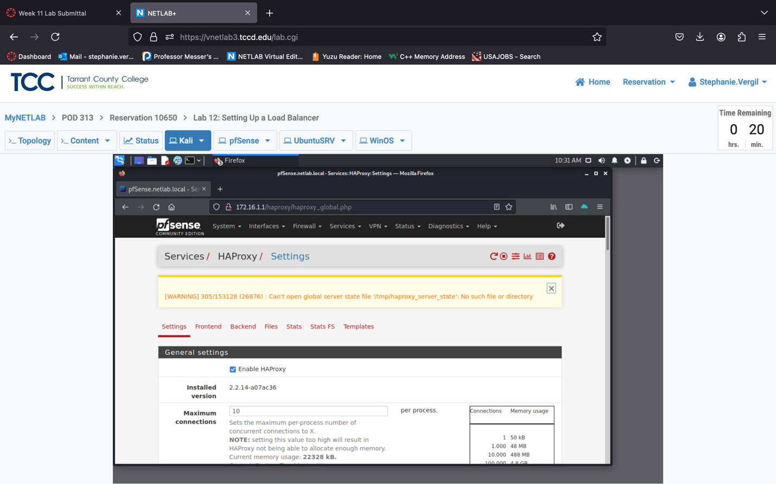

2.2 Test and Observe the Load Balance

1. In the Firefox browser, let’s start a private window. Click on the menu button at the top-right corner, then click the New Private Window option.
2. In the address bar, type the external/virtual server address shown in Section 2.1, step 18 (203.0.113.1). You can ignore the port number since it is on default HTTP port 80. Press Enter.
3. You should see the hello message from the WinOS server (this server is the first one in the Backend pool list)

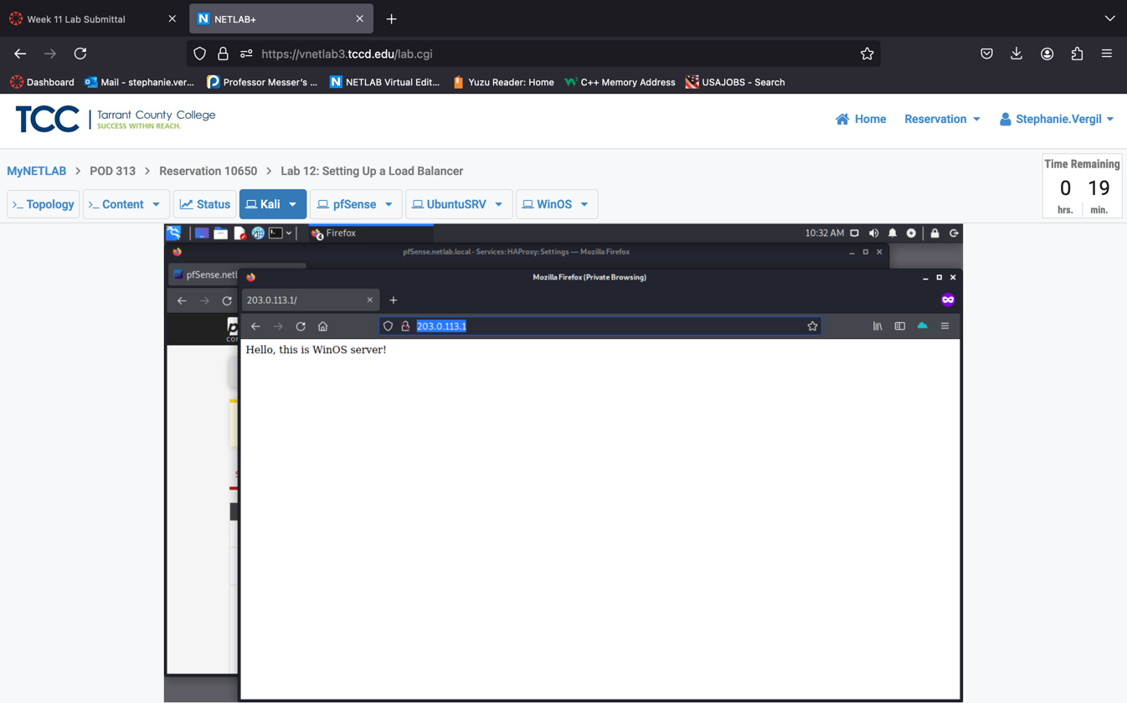

1. Click the Refresh button a few times to observe the change in the hello message. It should be alternating between the WinOS and UbuntuSRV servers.

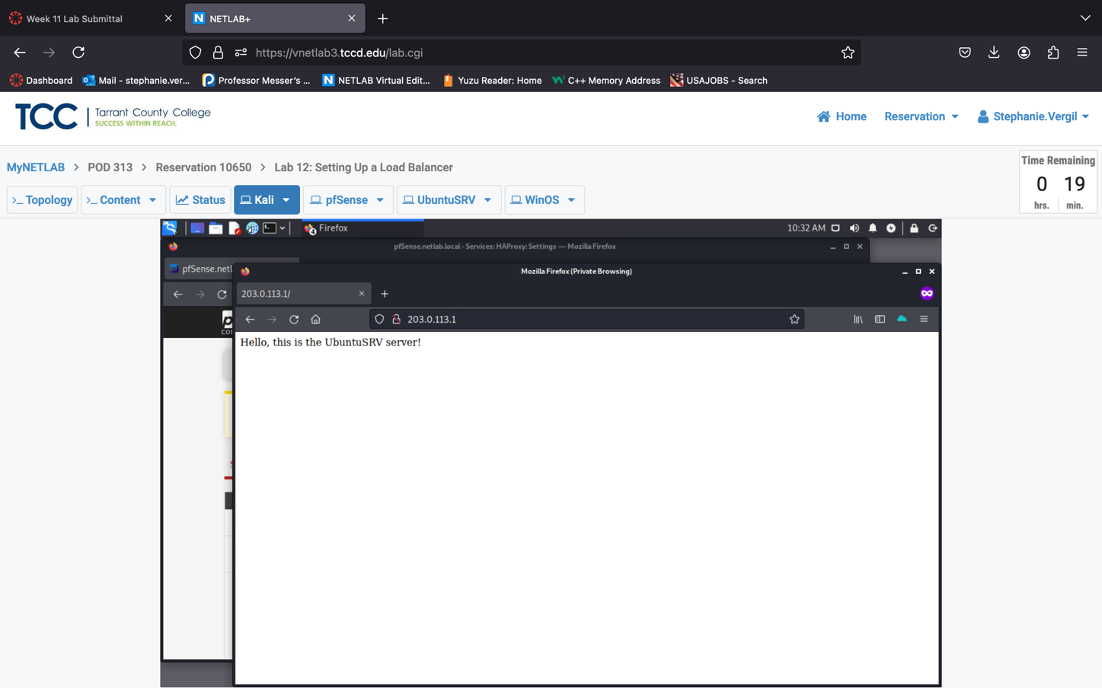

1. Lab is complete

Note: Load balancers distribute user traffic across multiple servers to keep websites running smoothly. However, if the load balancer moves a user’s session to a new server each time they refresh the page, they might lose data like a shopping cart—because each server doesn’t "remember" the previous session.

This is where **sticky sessions** (or session persistence) come in. With sticky sessions, the load balancer sends a user to the same server throughout their session. This way, data stays consistent for that user, like items in a shopping cart on an e-commerce site. To enable sticky sessions, most load balancers can be configured to identify users based on cookies or IP addresses, "sticking" each user to the same server for the duration of their session.